**EDI DESADV-** **Activation for warehouse and market reference**

|  |  |
| --- | --- |
| **Contact:** | SCM-EDI-Team |
| **E-Mail:** | [scm-edi-support@rewe-group.com](mailto:scm-edi-support@rewe-group.com) |

***Delivery planned for:***  Warehouse  Market Both

**We expect your DESADV reports for each delivery.**

**Note for market delivery:** REWE branches; REWE merchants; Petz- markets; Nahkauf; REWE Digital; Galeria Markthalle; Lekkerland; PENNY; real; REWE Dortmund.

**Note for warehouse delivery**: REWE Supplier Portal ([Link](https://supplier.rewe-group.com/wps/portal/rsp/lieferprozesse/))

***Important process notes (applicable cases are ticked)***

|  |  |  |
| --- | --- | --- |
| **Notice** | **Warehouse** | **Market** |
| Always refer to the respective order number in each DESADV message | **x** | **x** |
| The notification of free articles and advertising material is not supported | **x** | **x** |
| An SSCC/NVE is mandatory | **x** |  |
| Please note our DESADV guidelines | **x** | **x** |
| Follow-up notification is mandatory (DESADV is not available when the goods are delivered) |  | **x** |

***Please answer the following questions about market reference***

Type of article submission:

(please mark one variant) REWE-NAN Item-GTIN Bundle-GTIN Supp.-Art.-Nr.

*(****Note: For the warehouse reference, we only expect Bundle-GTINs or GTINs from order documents****)*

***General questions (please tick applicable cases)***

|  |  |  |
| --- | --- | --- |
| **Question** | **Warehouse** | **Market** |
| Do you use order splitting?  (Deliveries in several parts at the same time, so that several delivery notes are generated for one order) |  |  |
| Do you offer partial deliveries?  (Order quantity cannot be delivered 100%) |  |  |
| If so, with subsequent deliveries?  (Low quantity will be delivered as a partial delivery) |  |  |
| *Do you deliver weight-variable, non-equalized items?*  *(Notification is not given in pieces/quantities, but in kilograms/KG)* |  |  |

***Please answer the following questions about warehouse reference***

Do you work with sandwhich-pallets? Yes  No

*(Various articles placed one on top of the other and separated with an intermediate pallet)*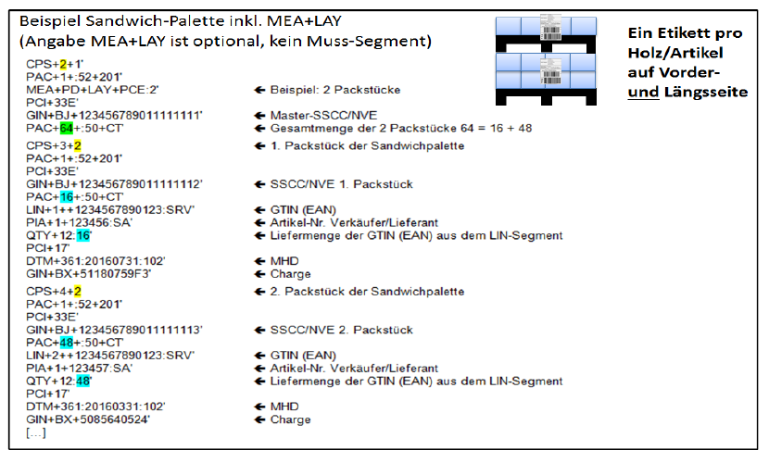

Do you work with mixed pallets? Yes  No

*(The mixed pallet is a pallet on which more than one item has been picked)*

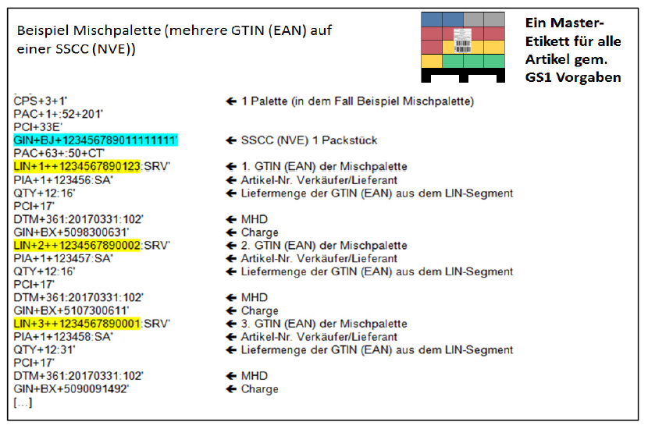

Are items subject to an MHD (best before date) subject to delivery? Yes  No

Are items that require batches delivered or is the batch number issued in the DESADV? Yes  No

***Note on DESADV test data****Please send us the corresponding test data for all constellations by e-mail to our support e-mail address* [***scm-edi-support@rewe-group.com***](mailto:scm-edi-support@rewe-group.com)

|  |
| --- |
| Comments: |

Thank you for your support!  
***SCM-EDI-Team - REWE Group***